**LiDAR Scan Types**

David Kristovich, dkristo@illinois.edu

These are types of scans that we often use for the lidars. A Fourth type of scan is defined by the lidar operator. Here is an overview diagram with example plots of data. More detail is below this first diagram.

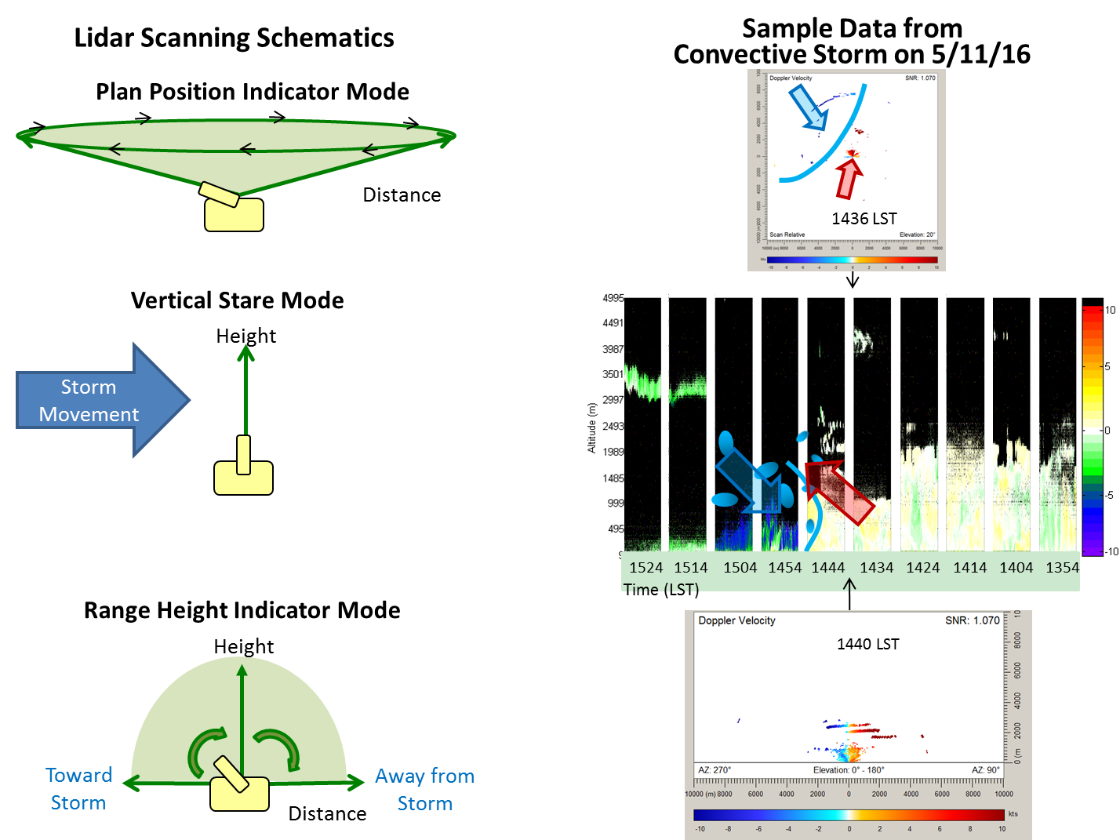

User Scan types are not shown in the diagram and are defined below.

**PPI – Plan Position Indicator Scan Type**

Produces files named VAD*.HPL



The lidar sweeps in a full circle - scans over a full range of azimuths, but keeps the elevation of the beam constant. So, for example, the lidar will scan, producing data with these characteristics:

Time Azimuth Angle Elevation Angle

1 0.000° 10° (almost horizontal, just 10 degrees above the level ground)

2 0.001° 10°

3 0.002° 10°

. .

. .

. .

. 359.999° 10°

**Stare Scan Type**

Produces files named Stare*.HPL



The lidar takes data by staring in one direction. Usually, stares are done with the lidar looking directly upward. The lidar measures the weather as it flows past the lidar. Azimuth and Elevation angles are constant – just time changes

Time Azimuth Angle Elevation Angle

1 90° 90° (Straight up, the azimuth angle is arbitrary - there is no horizontal direction)

2 90° 90° (Straight up, the azimuth angle is arbitrary)

3 90° 90° (Straight up, the azimuth angle is arbitrary)

. .

. .

. .

## 90° 90° (Straight up, the azimuth angle is arbitrary)

**RHI – Range Height Indicator Scan Type**

Produces files named RHI*.HPL



The lidar scans does a cross section or vertical slide through the atmosphere. For this, the Azimuth angle is kept constant, but the elevation angle varies. So, for example, the lidar will scan, producing data with these characteristics:

Time Azimuth Angle Elevation Angle

1 270° 0° (looking due west, horizontally)

2 270° 1° (looking due west, but at a little higher elevation)

. .

. .

. .

## 270° 89° (looking upward, but tilted a little toward the west)

## 270° 90° (looking directly upward)

## 270° 91° (looking upward, but tilted a little toward the east)

. .

. .

. .

## 270° 178°

## 270° 179°(looking east, but just slightly upward)

## 270° 180° (looking due east, horizontally)

**User-Defined Scan Type**

Produces files named User*.HPL

For this scan type, we give the lidar two directions (azimuth1, elevation1) and (azimuth2, elevation2)

The lidar moves from the first direction to the second at a speed that we determine.

Each beam recorded in the data is between the two points, as the lidar moves at a defined speed.